|  |
| --- |
|  |
| PROGRAMMING FUNDAMENTALS LAB |
| LAB – 10  K200239  ABDUL REHMAN SYED |
|  |
|  |
|  |

|  |
| --- |
|  |

Question 1 :

Code :

#include<stdio.h>

#include<string.h>

struct movietypes

{

char movie_name[100];

char movie_director[100];

char producer[100];

int year, n;

};

int main()

{

struct movietypes movie;

strcpy( movie. movie_name, "hello");

strcpy(movie. movie_director,"ABDULREHMAN");

strcpy(movie. producer,"ABDULREHMAN");

movie.year= 2010;

movie. n= 36000;

printf("Movie name : ");

puts(movie.movie_name);

printf("movie director : ");

puts(movie.movie_director);

printf("movie producer : ");

puts(movie.producer);

printf("YEAR = %d\n NUMBER OF COPIES= %d",movie.year,movie.n);

}

Output :

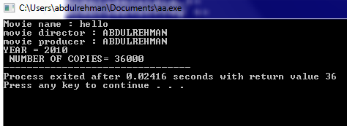

Question 2 :

Code :

#include<stdio.h>

#include<string.h>

struct menuItem

{

char menuItemType[20];

double menuPrice;

};

int main()

{

struct menuItem menu;

strcpy(menu.menuItemType, "seekh kabab");

menu.menuPrice = 130.75;

printf("Menu item : ");

puts(menu.menuItemType);

printf("Price = %.3f",menu.menuPrice);

}

Output :

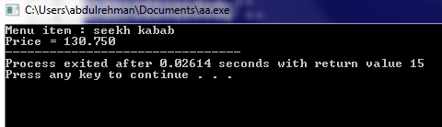

Question 3 :

Code :

#include<stdio.h>

#include<string.h>

struct checkingaccount

{

char accountHolder_name[100];

int account_number;

double account_balance;

double interest_rate;

};

int main()

{

struct checkingaccount account;

strcpy(account. accountHolder_name, "ABDULREHMAN");

account. account_number = 26356;

account. account_balance = 2387;

account.interest_rate = 4;

printf("Account holder name : ");

puts(account.accountHolder_name);

printf("Account number = %d\nAccount balance=%.4f\ninterest rate=%.4f",account.account_number,account.account_balance,account.interest_rate);

}

Output :

